Task 1:
Problem Description:
When a subclass inherits from a superclass, it also inherits its methods; however, it can also override the superclass methods (as well as declare and implement new ones). Consider the following Sports class:
class Sports{
String getName(){
return "Generic Sports";
}
void getNumberOfTeamMembers(){
System.out.println( "Each team has n players in " + getName() );
}
}
Next, we create a Soccer class that inherits from the Sports class. We can override the getName method and return a different, subclass-specific string:
class Soccer extends Sports{
@Override
String getName(){
return "Soccer Class";
}
}
Solution:
@Override
void getNumberOfTeamMembers(){
System.out.println("Each team has 11 players in " + getName());
}
Output:
Generic Sports
Each team has n players in Generic Sports
Soccer Class
Each team has 11 players in Soccer Class
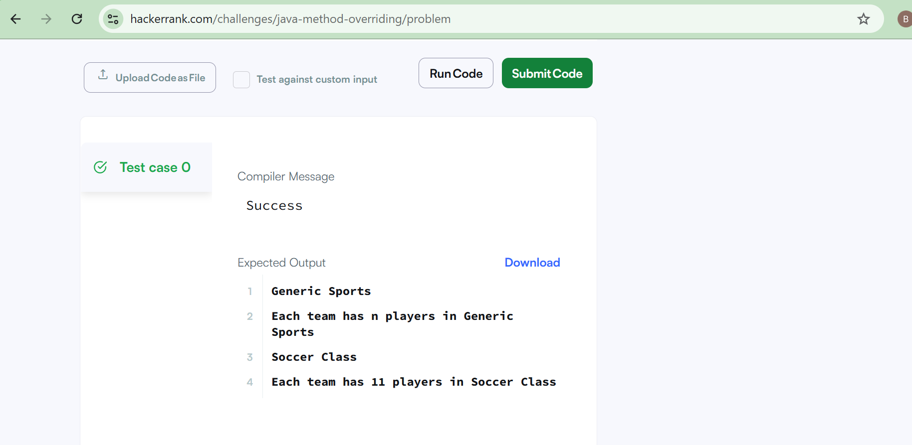
Task 2:
Problem Description:
When a method in a subclass overrides a method in superclass, it is still possible to call the overridden method using super keyword. If you write super.func() to call the function func(), it will call the method that was defined in the superclass.
You are given a partially completed code in the editor. Modify the code so that the code prints the following text:
Hello I am a motorcycle, I am a cycle with an engine.
My ancestor is a cycle who is a vehicle with pedals.
Solution:
String temp = super.define_me();
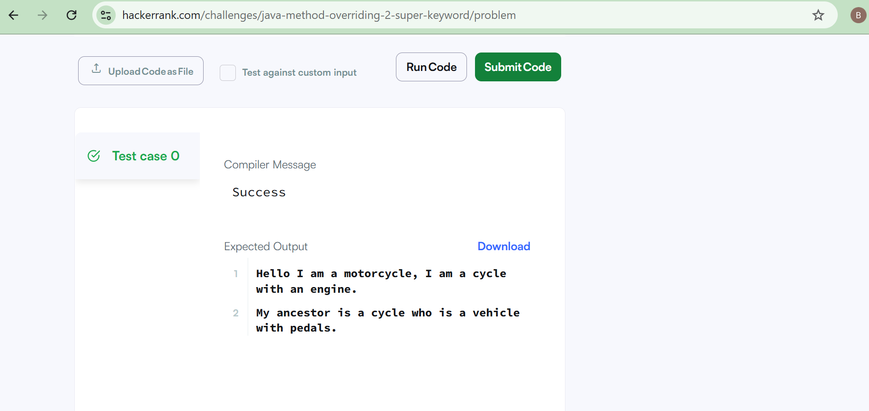

Task 3:
Problem Description:
"The singleton pattern is a design pattern that restricts the instantiation of a class to one object. This is useful when exactly one object is needed to coordinate actions across the system."
- Wikipedia: Singleton Pattern

Complete the Singleton class in your editor which contains the following components:
- A private Singleton non parameterized constructor.
- A public String instance variable named .
- Write a static method named getSingleInstance that returns the single instance of the Singleton class.
Once submitted, our hidden Solution class will check your code by taking a String as input and then using your Singleton class to print a line.
Solution:
class Singleton {

public String str;
private static Singleton instance;

// Private constructor
private Singleton() {
}

// Static method to get single instance
public static Singleton getSingleInstance() {
if (instance == null) {
instance = new Singleton();
}
return instance;
}
}

Sample Input
hello world
Sample Output
Hello I am a singleton! Let me say hello world to you
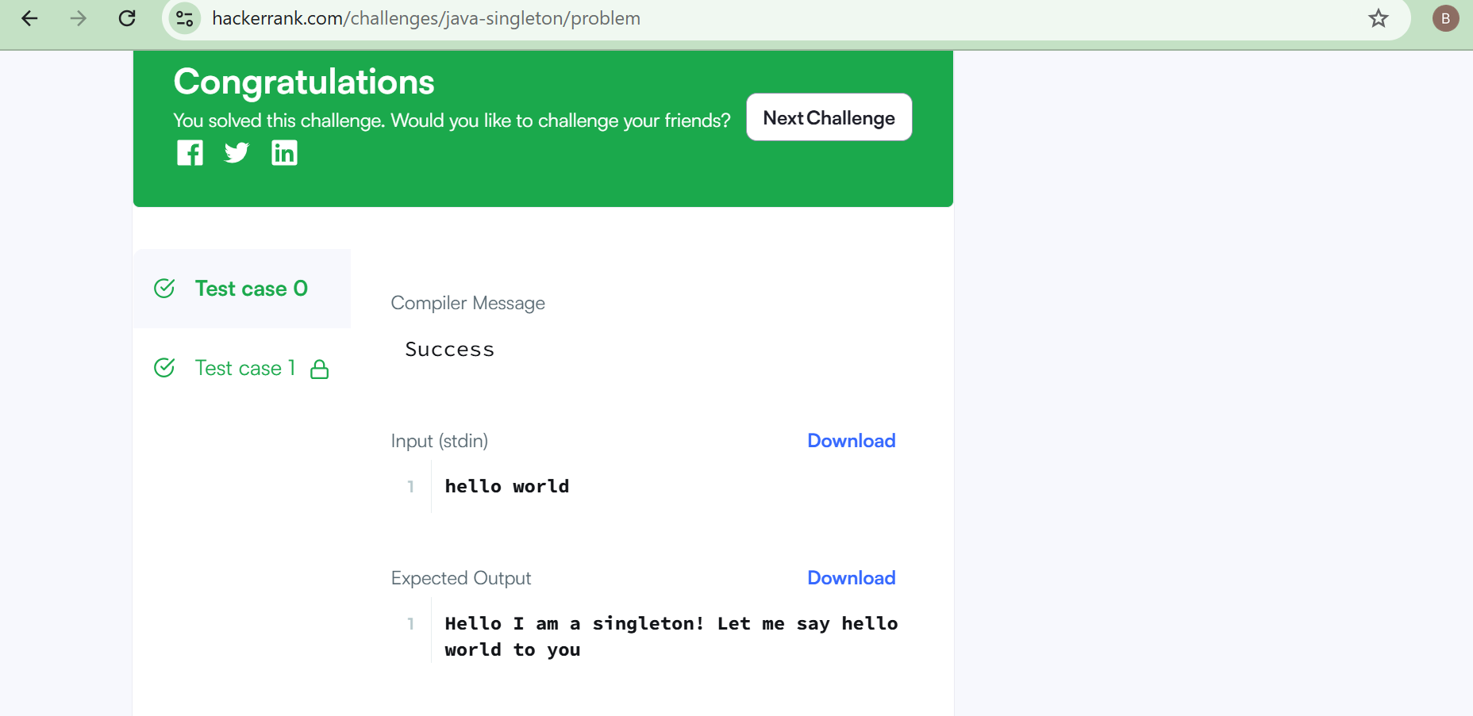
Task 4:
Problem Description:
Part I: Implement Three Different Visitors
Each class has three methods you must write implementations for:
- getResult(): Return an integer denoting the , which is different for each class:
  - The SumInLeavesVisitor implementation must return the sum of the values in the tree's leaves only.
  - The ProductRedNodesVisitor implementation must return the product of values stored in all red nodes, including leaves, computed modulo . Note that the product of zero values is equal to .
  - The FancyVisitor implementation must return the absolute difference between the sum of values stored in the tree's non-leaf nodes at even depth and the sum of values stored in the tree's green leaf nodes. Recall that zero is an even number.
- visitNode(TreeNode node): Implement the logic responsible for visiting the tree's non-leaf nodes such that the getResult method returns the correct for the implementing class' visitor.
- visitLeaf(TreeLeaf leaf): Implement the logic responsible for visiting the tree's leaf nodes such that the getResult method returns the correct for the implementing class' visitor.

Part II: Read and Build the Tree
Read the -node tree, where each node is numbered from to . The tree is given as a list of node values (), a list of node colors (), and a list of edges. Construct this tree as an instance of the Tree class. The tree is always rooted at node number .
Your implementations of the three visitor classes will be tested on the tree you built from the given input.
Solution:
class SumInLeavesVisitor extends TreeVis {
int sum = 0;

public int getResult() {
return sum;
}

public void visitNode(TreeNode node) {
// do nothing
}

public void visitLeaf(TreeLeaf leaf) {
sum += leaf.getValue();
}
}
class ProductOfRedNodesVisitor extends TreeVis {
long product = 1;
final int MOD = 1000000007;

public int getResult() {
return (int) product;
}

public void visitNode(TreeNode node) {
if (node.getColor() == Color.RED) {
product = (product * node.getValue()) % MOD;
}
}

public void visitLeaf(TreeLeaf leaf) {
if (leaf.getColor() == Color.RED) {
product = (product * leaf.getValue()) % MOD;
}
}
}
class FancyVisitor extends TreeVis {
int evenDepthSum = 0;
int greenLeafSum = 0;

public int getResult() {
return Math.abs(evenDepthSum - greenLeafSum);
}

public void visitNode(TreeNode node) {
if (node.getDepth() % 2 == 0) {
evenDepthSum += node.getValue();
}
}

public void visitLeaf(TreeLeaf leaf) {
if (leaf.getColor() == Color.GREEN) {
greenLeafSum += leaf.getValue();
}
}
}

Sample Input
5
4 7 2 5 12
0 1 0 0 1
1 2
1 3
3 4
3 5
Sample Output
24
40
15
Task 5:
Problem Description:
Java Iterator class can help you to iterate through every element in a collection. Here is a simple example:
import java.util.*;
public class Example{

public static void main(String []args){
ArrayList mylist = new ArrayList();
mylist.add("Hello");
mylist.add("Java");
mylist.add("4");
Iterator it = mylist.iterator();
while(it.hasNext()){
Object element = it.next();
System.out.println((String)element);
}
}
}
In this problem you need to complete a method func. The method takes an ArrayList as input. In that ArrayList there is one or more integer numbers, then there is a special string "###", after that there are one or more other strings. A sample ArrayList may look like this:
element[0]=>42
element[1]=>10
element[2]=>"###"
element[3]=>"Hello"
element[4]=>"Java"
You have to modify the func method by editing at most 2 lines so that the code only prints the elements after the special string "###". For the sample above the output will be:
Hello
Java
Solution:
Object element = it.next();
if (element instanceof String && element.equals("###"))
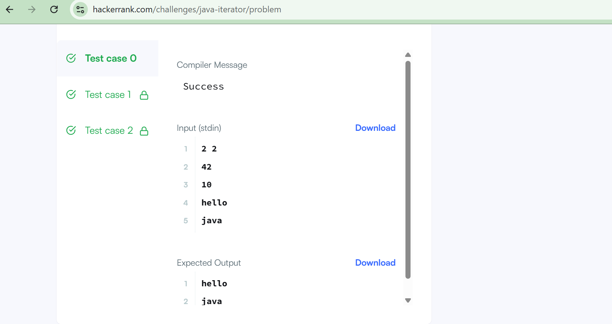
Task 6:
Problem Description:
A Java interface can only contain method signatures and fields. The interface can be used to achieve polymorphism. In this problem, you will practice your knowledge on interfaces.
You are given an interface AdvancedArithmetic which contains a method signature int divisor_sum(int n). You need to write a class called MyCalculator which implements the interface.
divisorSum function just takes an integer as input and return the sum of all its divisors. For example divisors of 6 are 1, 2, 3 and 6, so divisor_sum should return 12. The value of n will be at most 1000.
Read the partially completed code in the editor and complete it. You just need to write the MyCalculator class only. Your class shouldn't be public.
Solution:
class MyCalculator implements AdvancedArithmetic {

public int divisor_sum(int n) {
int sum = 0;

for (int i = 1; i <= n; i++) {
if (n % i == 0) {
sum += i;
}
}

return sum;
}
}
Sample Input
6
Sample Output
I implemented: AdvancedArithmetic
12
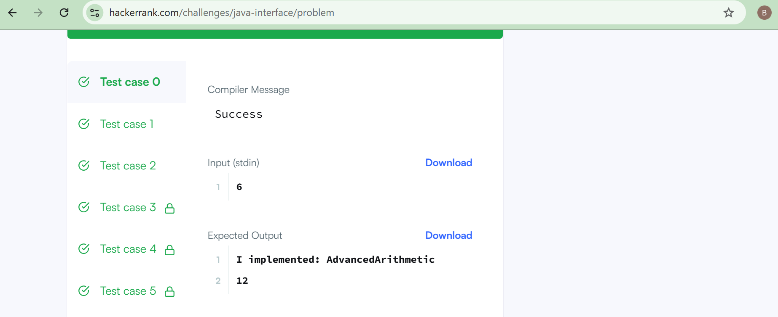
Task 7:
Problem Description:
n computer science, a set is an abstract data type that can store certain values, without any particular order, and no repeated values(Wikipedia). is an example of a set, but is not a set. Today you will learn how to use sets in java by solving this problem.
You are given pairs of strings. Two pairs and are identical if and . That also implies is not same as . After taking each pair as input, you need to print number of unique pairs you currently have.
Complete the code in the editor to solve this problem.
Solution:
Scanner sc = new Scanner(System.in);
int n = sc.nextInt();

HashSet<String> set = new HashSet<>();

for (int i = 0; i < n; i++) {
String a = sc.next();
String b = sc.next();

set.add(a + " " + b);
System.out.println(set.size());
}

Sample Input
5
john tom
john mary
john tom
mary anna
mary anna
Sample Output
1
2
2
3
3
Task 8:
Problem Description:
According to Wikipedia, a factory is simply an object that returns another object from some other method call, which is assumed to be "new".
In this problem, you are given an interface Food. There are two classes Pizza and Cake which implement the Food interface, and they both contain a method getType().
The main function in the Main class creates an instance of the FoodFactory class. The FoodFactory class contains a method getFood(String) that returns a new instance of Pizza or Cake according to its parameter.
You are given the partially completed code in the editor. Please complete the FoodFactory class.
Solution:
if (order.equalsIgnoreCase("pizza")) {
return new Pizza();
} else if (order.equalsIgnoreCase("cake")) {
return new Cake();
}
return null;

Sample Input 1
cake
Sample Output 1
The factory returned class Cake
Someone ordered a Dessert!
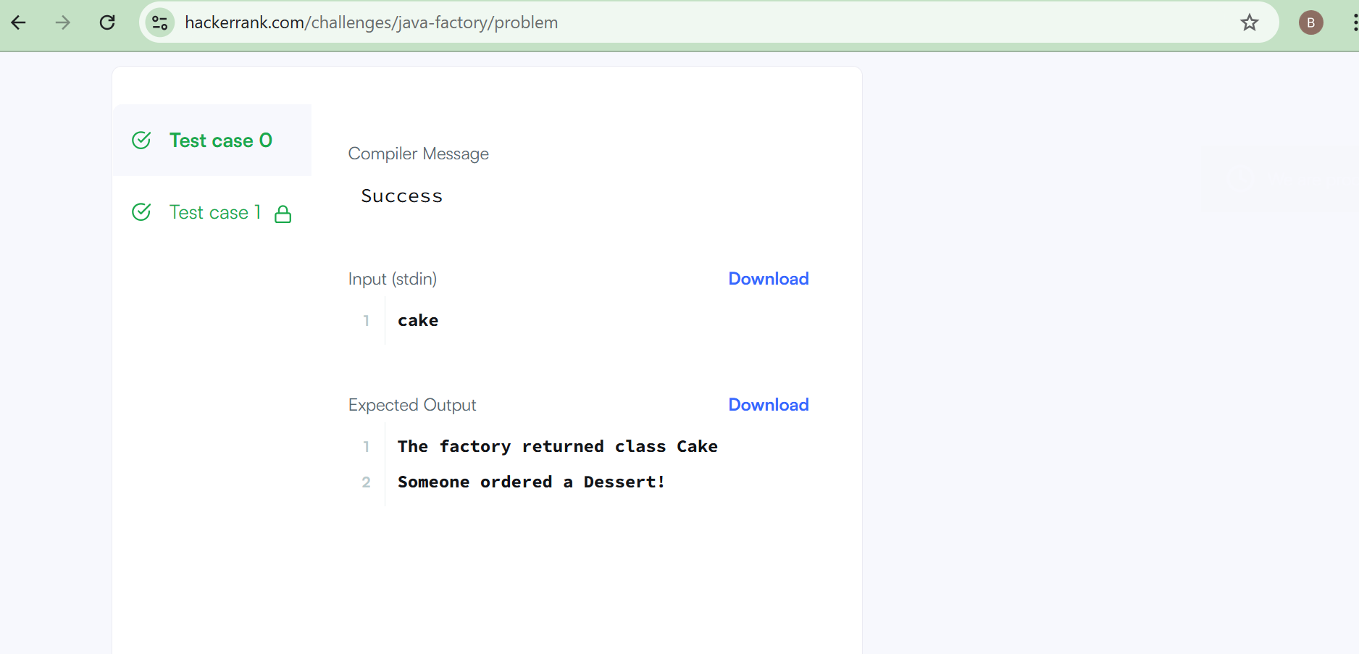
Task 9:
Problem Description:
You are required to compute the power of a number by implementing a calculator. Create a class MyCalculator which consists of a single method long power(int, int). This method takes two integers, and , as parameters and finds . If either or is negative, then the method must throw an exception which says "". Also, if both and are zero, then the method must throw an exception which says ""
For example, -4 and -5 would result in .
Complete the function power in class MyCalculator and return the appropriate result after the power operation or an appropriate exception as detailed above.
Solution:
long power(int n, int p) throws Exception {
if (n < 0 || p < 0) {
throw new Exception("n or p should not be negative.");
}
if (n == 0 && p == 0) {
throw new Exception("n and p should not be zero.");
}

return (long) Math.pow(n, p);
}
Sample Input 0
3 5
2 4
0 0
-1 -2
-1 3
Sample Output 0
243
16
java.lang.Exception: n and p should not be zero.
java.lang.Exception: n or p should not be negative.
java.lang.Exception: n or p should not be negative.
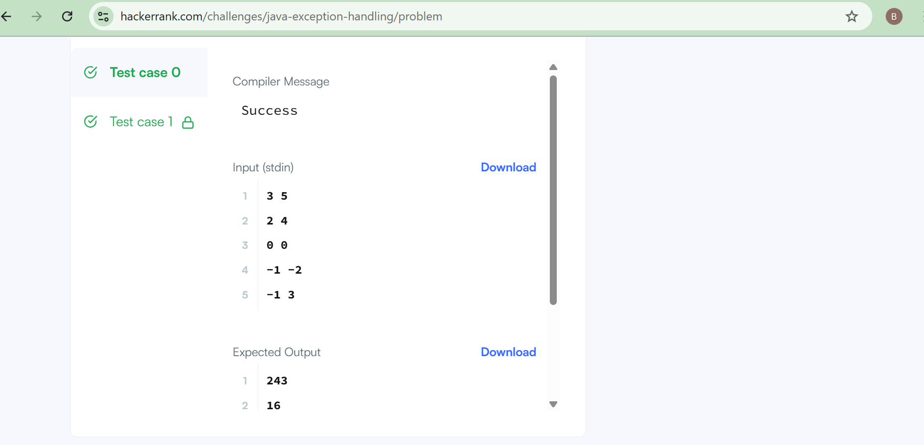
Task 10:
Problem Description:
Exception handling is the process of responding to the occurrence, during computation, of exceptions – anomalous or exceptional conditions requiring special processing – often changing the normal flow of program execution. (Wikipedia)

Java has built-in mechanism to handle exceptions. Using the try statement we can test a block of code for errors. The catch block contains the code that says what to do if exception occurs.
This problem will test your knowledge on try-catch block.
You will be given two integers and as input, you have to compute . If and are not bit signed integers or if is zero, exception will occur and you have to report it. Read sample Input/Output to know what to report in case of exceptions.
Solution:
public static void main(String[] args) {
try {
Scanner sc = new Scanner(System.in);
int x = sc.nextInt();
int y = sc.nextInt();
int result = x / y;
System.out.println(result);
} catch (InputMismatchException e) {
System.out.println("java.util.InputMismatchException");
} catch (ArithmeticException e) {
System.out.println(e);
}
}
}
Sample Input 0:
10
3
Sample Output 0:
3
